Project Title: **Sneaky Shoes E-Commerce**

Group Name: **UNT-DEV**

Team Members List:

* RAHEEM ALI
* GIRISH VARDHAN GAVIREDDY
* SAI KIRAN REDDY SOMA
* LETHASWI THOKALA
* PRATHYUSHA REDDY PIPPIRADA
* LIKHITHA REDDY SAMA
* SAI VENKATARAMA INNAMURI

**Phase 3:** (Deadline: 05-01-2023)

In this phase Our team plans to complete and successfully run the project.

|  |  |  |
| --- | --- | --- |
| S.no | Features | Priority |
| 1. | Invoice | P1 |
| 2. | Email Notification | P2 |
| 3. | Web Testing | P3 |
|  |  |  |

# Invoice:

In Sneaky Shoes e-commerce, an order invoice and an email invoice serve different purposes, but both are important for the customer and the seller.

* An order invoice is a document that provides the customer with a summary of the order they have placed, including the items purchased, the quantities, the prices, and any applicable taxes or discounts. It typically includes the order number, the date of the order, the billing and shipping addresses, and the payment method. The order invoice is usually generated automatically by the e-commerce platform once the order is placed and may be included in the order confirmation email sent to the customer.
* An email invoice, on the other hand, is a document that is sent to the customer after the order has been shipped or fulfilled. It provides a summary of the items that were shipped or fulfilled, including any shipping and handling fees or taxes. The email invoice serves as a record of the transaction and may be used by the customer for accounting or tax purposes. It also provides an opportunity for the seller to thank the customer for their purchase and to request feedback or a review.
* Both the order invoice and the email invoice are important for the customer because they provide a clear record of the transaction and can help to resolve any issues or disputes that may arise. For the seller, they serve as a record of the transaction and may be used for accounting or inventory purposes.

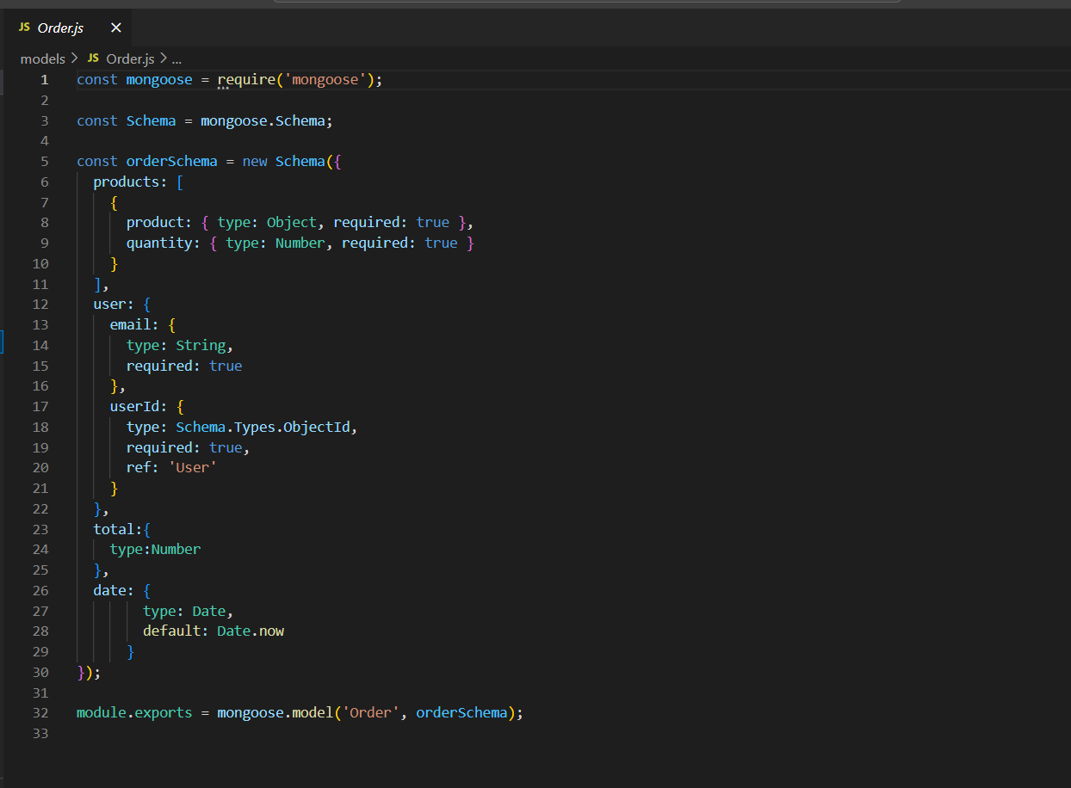

# Email Notification

Email notifications are an important part of any Sneaky shoe’s website, as they help to keep customers informed about their orders, payments, and other important updates. Here are some common types of email notifications that a website send:

* Order confirmation
* Payment confirmation
* Shipping confirmation

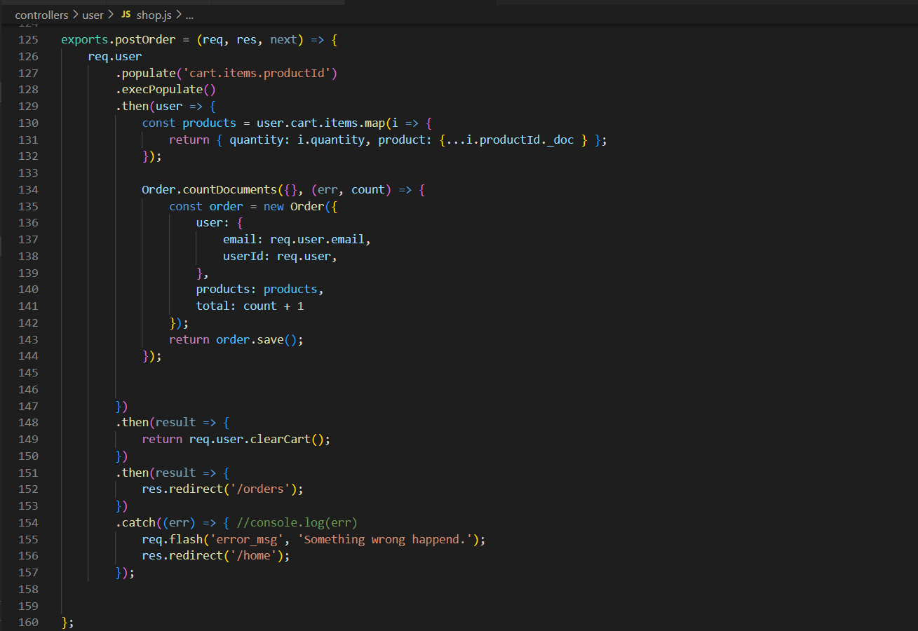

# Test Cases or Website Testing.:

1. Add Item: If you add any product to the shopping cart then then that specific item should be find or added into the shopping cart.
2. Delete from Shopping Cart: If user wants to delete an item from the shopping cart it should remove that specific product from the shopping cart.
3. Calculating Price: During this add to cart and deleting the item from the cart the price of all the products should be accurate even after deleting or adding a product into the shopping cart.
4. Payment error: If the Payment id i.e., UPI id is wrong then it will throw an error.
5. Empty Shopping cart: If a user tries to have access to the payment page without any product, then it won’t allow it.
6. User Login: If the credentials of the user are wrong then they can’t access our core features of the website.
7. If a user closes a tab without a payment, then all the products can be found in a shopping cart.

**Report Code Inspection**

During the code Inspection the other them suggest us to use a dummy payment system due to less duration of time. Other than that, we are on the track for the development of the website.

**Report Reflection**

But during the development process we found many bugs for the dummy payment system. This is why in this phase we have successfully complete the payment integration of Razorpay API. By this A user can easily buy the items from the website.

After the code inspection, we had a team discussion and decided to implement the real payment API integration into our system for two reasons.

1. Test securely with this Razorpay api integration for the payment system.
2. Able to handle a lot of test cases by itself. So, the team can focus on other features rather than the bug driven dummy payment system.

**User Manual**

[**https://sneaky-shoes.onrender.com**](https://sneaky-shoes.onrender.com)

**Or to set up locally follow this step:**

1. From GitHub Repository (https://github.com/ralei0/UNT-Dev), click on Clone
2. Copy the clone URL
3. In Terminal (Mac) or command line (Windows git bash), move to local directory
4. Use the **git clone** command **along with the copied URL.**
5. After cloning, in Terminal type: “**npm install**” and “**npm install express”**.
6. The finally run script: “**node app.js”**.
7. Open the browser and in type: “localhost:3000”

**Report Member Contribution**

|  |  |
| --- | --- |
| Team Member’s Name | Contribution |
| RAHEEM ALI | Worked on email and payment notification. Also Made several important Test Cases. |
| GIRISH VARDHAN GAVIREDDY | Completed the invoice schema for the website |
| SAI KIRAN REDDY SOMA | Complete the backend of invoices |
| LETHASWI THOKALA | Helped in the User improvement |
| PRATHYUSHA REDDY PIPPIRADA | Focused on the frontend part of the payment and invoices |
| LIKHITHA REDDY SAMA | Worked on error handling of the website. |
| SAI VENKATARAMA INNAMURI | Helped in handling Test Cases. |